HTT completion guidelines

Contents
Purpose 2
Scope 2
General guidelines 3
Uniform Encoding Format 4
Tab Specific Guidelines 4
Introduction 4
A. HTT General 4
3.2 Over-collateralisation (OC) 4
6. Covered Assets - Currency 4
7. Covered Bonds – Currency 5
8. Covered Bonds – Breakdown by interest rate 5
B1. HTT Mortgage Assets 5
4.Breakdown by Geography 5
5. Breakdown by regions of main country of origin 6
6. Breakdown by Interest Rate 9
7. Breakdown by Repayment Type 9
8. Loan Seasoning 9
10. Loan Size information 9
B2. HTT Public Sector Assets 16
2. Size Information 16
E. Optional ECB-ECAIs data 19
Section 3.2 Arrears 19

Purpose

Currently over 125 active cover pools from 106 issuers in 18 jurisdiction, representing around 70% of the global outstanding covered bond market provides the Covered Bond Label the critical mass to be considered as a standard setter for both established and new jurisdiction of this market. Against this background it is of paramount importance to be able to produce consistent Harmonised Transparency Templates (HTT) which can be easily compared both within the same jurisdiction and also cross-country. The industry already has made a great effort by producing the HTT to decide upon a shared common Excel reporting tool to be used for the cover pool reporting. In order to reap the potentiality of the HTT the Covered Bond Label decided to provide to labelled issuers the following draft of HTT completion guidelines, which will be object of discussion of the Label Committee Meeting of the 24 April 2019 and open to comments from national coordinators as well as the wider Label community.

Scope

Bearing in mind the balance of providing consistent HTT reports throughout the Label issuers and respecting national or issuer-specific particularities, this completion guidelines aims at sections which are of easy harmonisation and which necessitate more clarity in order not to provide misleading information among the HTTs.

These guidelines are to be considered as a complement to the general HTT revision process which follows the procedures decided and applied by the Label Committee.

General guidelines

- Every pool has one separate HTT. Issuers with more than one cover pool have to present as many separate HTTs as the number of pools.
- All cells that include “[For completion]” and “[Mark as ND if not relevant]” needs to be completed
- The "[For completion]" or "[Mark as ND if not relevant]" cells could be filled with:
  - A Numbers: Please insert the appropriate data
  - B Letters: Please insert either No Data (ND):
    - ND1: Please complete the cell with ND1 when the information is not applicable for the jurisdiction
    - ND2: Please complete the cell with ND2 when the information is not relevant for the issuer and/or CB programme at the present time
    - ND3: Please complete the cell with ND3 when the information is not available at the present time
- Please note that where provided the percentage cells will be automatically completed by the spreadsheet.
- The wording of the tabs referring to the HTT (the ones with an orange tab colour) are not to be changed.
- Should you wish to insert your National Transparency Template worksheet(s) in the HTT, please follow our instructions in the box below.
  - Please do not forget to change the name of the worksheet in order to be consistent with the numbering of the existing ones (starting with D.).
  - Please update the Introduction Tab accordingly.
- Please delete tab D (Insert National Transparency Template) and the example tabs if unused.
  - Please update the introduction Tab accordingly.
- Should you make references to external documents or cells in this document, please insert the hyperlink.
- Since HTT 2018 various fields as well as the amount of row and columns are blocked in order to guarantee the uniformity of the HTT architecture which enables running automated reporting programs. In order to guarantee this uniformity the Secretariat will not provide ‘unprotected’ HTTs to the issuers.

How to import an excel worksheet
- Click on the tab of the worksheet you want to import  - Select "Move or Copy" | 3. Select the excel file where you want to transfer your worksheet from the dropdown menu  4. In the box Before Sheet, please select "(move to end)"  5. Do not forget to tick the "Create a copy" box and press ok
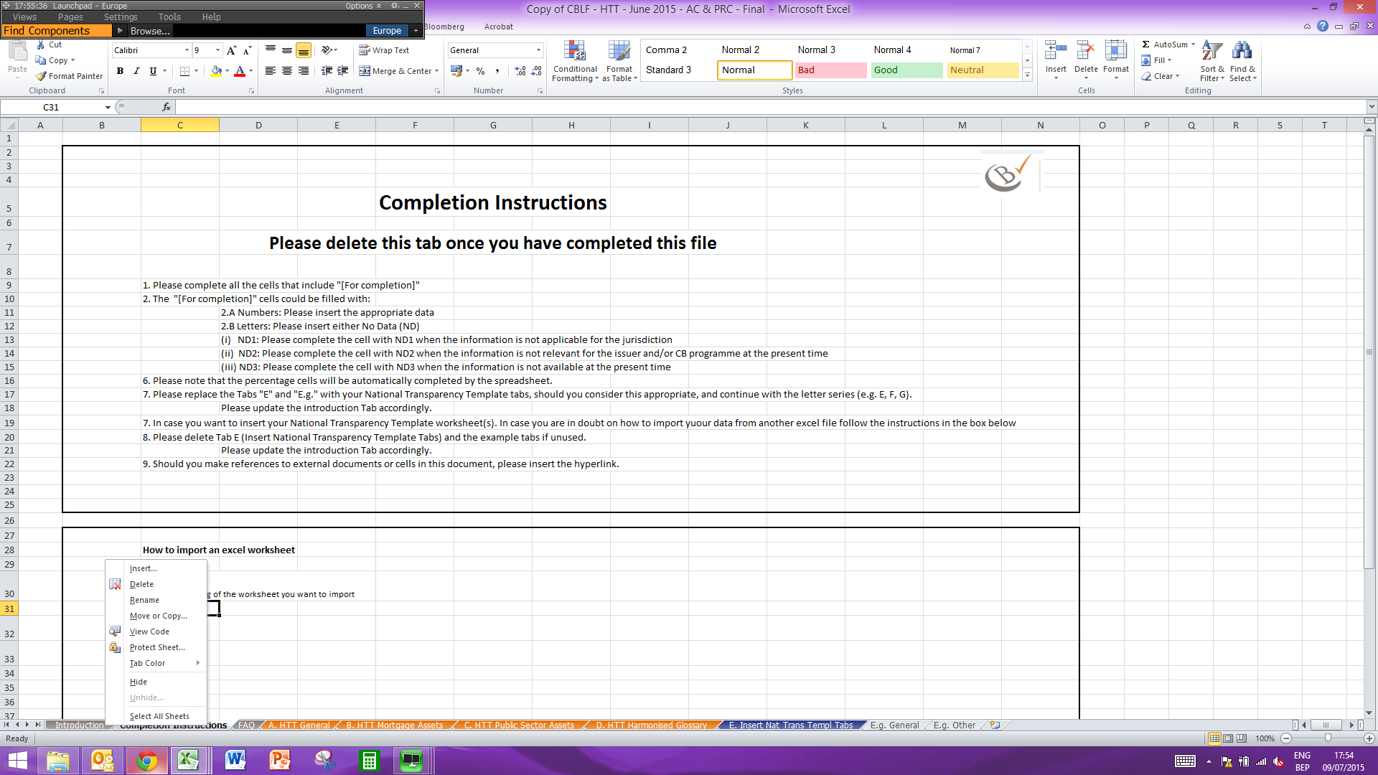 | 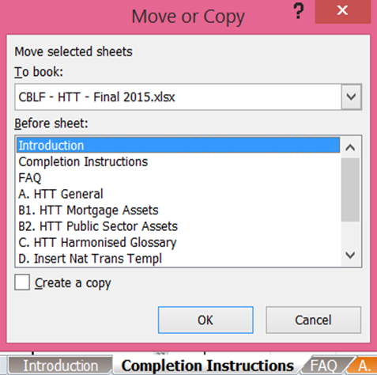

Uniform Encoding Format

Throughout the HTT we aim at having a uniform representation of the various figures according to the following scheme:

- Date: DD/MM/YYY
- integer numbers (eg. Number of loans): #,###
- volumes (eg: covered bond outstanding): #,###.#
- percentage (eg. OC level) #.#%
- years (eg. Average maturity of covered bonds) ##.#

Tab Specific Guidelines
Here you find guidelines for specific locations in the different tabs of the HTT in order to prevent providing misleading information.

Introduction
- Reporting Date: date in which the HTT has been published
- Cut-off Date: date the figures refer to. The last date of a quarter needs to be the last calendar day. For example Friday 29 March 2019 was the last working day of Q1 2019, but here we would like to see as cut-off date 31 March 2019 even if it falls on a Sunday.

HTT General
Here below are reported the locations of Tab A. HTT General for which the Secretariat would like to provide further guidance:

3.2 Over-collateralisation (OC)
- Legal/Regulatory – the minimal OC level prescribed by national law
- Minimum committed – the minimal OC level the issuer is committed to keep (if there is no committed value, please insert here the legal/regulatory OC

Cover Pool Composition
The Sum which figures under line G.3.3.6 needs to be equal to the Total Cover Assets as presented in line G.3.1.1

3.6. Covered Assets - Currency
The columns C and D “Nominal [before hedging] (mn)” and “Nominal [after hedging] (mn)” should be completed as follows:
- The nominal value for both columns is always expressed in the Domestic currency stated in cell C3 of this worksheet
- The sum of the Total which is calculated in cells C129 and D129 do not necessarily be the same as the exchange rates for hedging purposes and for reporting purposes may differ. It is important that the nominal after hedging value is equal to the total cover assets (row G.3.1.1). need to be the same.
Moreover, hedged assets should not disappear from the after hedging column. The currency which is hedged against will have a higher value in column D with respect to column C in the same proportion of the decrease of the currency/ies which was/were hedged. In the box below please find an example:
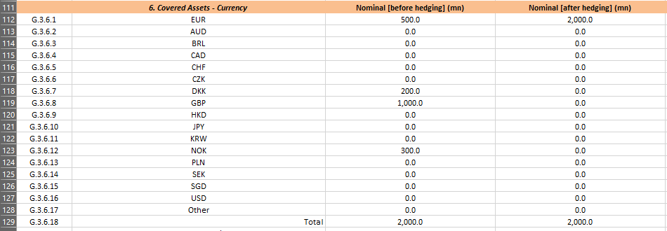
In this hypothetical case a Euro-based issuer (domestic currency reporting in EUR, assuming that reporting and hedging exchange rates are the same) has covered assets in the Eurozone, Denmark, Norway and the UK. After hedging all the non-Euro assets against the Euro in the after hedging scenario there will be only outstanding in Euro.

NB: the values before hedging are all expressed in the reporting currency reported in Cell C3 of tab A. HTT General and in the tabs B1-B3. The issuer is doing the calculation using the Exchange Rate.

3.7. Covered Bonds – Currency
Same approach as explained for section 6. Cover Assets – Currency

3.8. Covered Bonds – Breakdown by interest rate
Same approach as explained for section 6. Cover Assets – Currency

B1. HTT Mortgage Assets

7.4. Breakdown by Geography

In this section besides the breakdown by country at the same time also the breakdown between residential and commercial loans is provided.
TWO POSSIBLE APPROACHES can be used:
Approach A:
The breakdown is provided separately for residential loans and commercial loans, thus reaching 100% in both columns.
Approach B:
The breakdown is provided for both types of loans together, thus 100% is reached by adding the breakdowns in both columns.

7.5. Breakdown by regions of main country of origin
In order to provide a more consistent comparison of the cover pools of the same jurisdictions, together with the support of the respective national coordinators, the Covered Bond Label presents the list of regions in which to report the cover assets. Here below the list of regions in the countries ordered alphabetically:
- Austria:
  - Wien
  - Niederösterreich
  - Oberösterreich
  - Salzburg
  - Tirol
  - Steiermark
  - Kärnten
  - Burgenland
  - Vorarlberg
- Belgium:
  - Antwerpen
  - Vlaams-Brabant
  - Oost-Vlaanderen
  - Brussels
  - West-Vlaanderen
  - Limburg
  - Liège
  - Hainaut
  - Brabant Wallon
  - Namur
  - Luxembourg
- Canada:
  - Alberta
  - British Columbia
  - Manitoba
  - New Brunswick
  - Newfoundland and Labrador
  - Northwest Territories
  - Nova Scotia
  - Nunavut
  - Ontario
  - Prince Edward Island
  - Quebec
  - Saskatchewan
  - Yukon
- Denmark:
  - Hovedstaden
  - Sjælland
  - Syddanmark
  - Midtjylland
  - Nordjylland
- Finland [still to be finalised]:
  - Aland Islands
  - Central Finland
  - Central Ostrobothnia
  - Etela-Savo
  - Kainuu
  - Kanta-Hame
  - Kymenlaakso
  - Lapland
  - North Karelia
  - North Ostrobothnia
  - Ostrobothnia
  - Paijat-Hame
  - Pirkanmaa
  - Pohjois-Savo
  - Satakunta
  - South Karelia
  - South Ostrobothnia
  - Uusimaa
  - Varsinais-Suomi
- France:
  - Auvergne-Rhône-Alpes
  - Bourgogne-Franche-Comté
  - Bretagne
  - Centre-Val-de-Loire
  - Grand-Est
  - Corse
  - Outremer
  - Occitanie
  - Normandie
  - Ile-de-France
  - Nouvelle-Aquitaine
  - Hauts-de-France
  - Pays-de-la-Loire
  - Provence-Alpes-Côte-d'Azur
- Germany:
  - Baden-Württemberg
  - Bavaria
  - Berlin
  - Brandenburg
  - Bremen
  - Hamburg
  - Hesse
  - Mecklenburg-Western Pomerania
  - Lower Saxony
  - North Rhine-Westphalia
  - Rhineland-Palatinate
  - Saarland
  - Saxony
  - Saxony-Anhalt
  - Schleswig-Holstein
  - Thuringia
- Greece:
  - Aegean Islands
  - Attica
  - Central Greece
  - Creta
  - Epirus
  - Ionian Islands
  - Macedonia
  - Peloponnese
  - Thessaloniki
  - Thessaly
  - Thrace
- Hungary:
  - Budapest
  - Baranya
  - Bács-Kiskun
  - Békés
  - Borsod-Abaúj-Zemplén
  - Csongrád-Csanád
  - Fejér
  - Győr-Moson-Sopron
  - Hajdú-Bihar
  - Heves
  - Jász-Nagykun-Szolnok
  - Komárom-Esztergom
  - Nógrád
  - Pest
  - Somogy
  - Szabolcs-Szatmár-Bereg
  - Tolna
  - Vas
  - Veszprém
  - Zala
- Ireland:
  - Carlow
  - Cavan
  - Clare
  - Cork
  - Donegal
  - Dublin
  - Galway
  - Kerry
  - Kildare
  - Kilkenny
  - Laois
  - Leitrim
  - Limerick
  - Longford
  - Louth
  - Mayo
  - Meath
  - Monaghan
  - Offaly
  - Roscommon
  - Sligo
  - Tipperary
  - Waterford
  - Westmeath
  - Wexford
  - Wicklow
- Italy:
  - Abruzzo
  - Basilicata
  - Calabria
  - Campania
  - Emilia Romagna
  - Friuli Venezia Giulia
  - Lazio
  - Liguria
  - Lombardia
  - Marche
  - Molise
  - Piemonte
  - Puglia
  - Sardegna
  - Sicilia
  - Toscana
  - Trentino Alto Adige
  - Umbria
  - Valle d'Aosta
  - Veneto
- Netherlands:
  - Brabant
  - Drenthe
  - Flevoland
  - Friesland
  - Gelderland
  - Groningen
  - Limburg
  - Noord-Holland
  - Overijssel
  - Utrecht
  - Zeeland
  - Zuid-Holland
- Norway:
  - Akershus
  - Aust-Agder
  - Buskerud
  - Finmark
  - Hedmark
  - Hordaland
  - Møre og Romsdal
  - Nordland
  - Oppland
  - Oslo
  - Østfold
  - Rogaland
  - Sogn og Fjordane
  - Svalbard
  - Telemark
  - Troms
  - Trøndelag
  - Vest-Agder
  - Vestfold
- Poland:
  - Dolnośląskie
  - Kujawsko-Pomorskie
  - Lubelskie
  - Lubuskie
  - Łódzkie
  - Małopolskie
  - Mazowieckie
  - Opolskie
  - Podkarpackie
  - Podlaskie
  - Pomorskie
  - Śląskie
  - Świętokrzyskie
  - Warmińsko-Mazurskie
  - Wielkopolskie
  - Zachodniopomorskie
- Portugal:
  - North
  - Center
  - Lisbon
  - Alentejo
  - Algarve
  - Madeira
  - Azores
- Republic of Korea (South):
  - Busan
  - North Chungcheong
  - South Chungcheong
  - Daejeon
  - Daegu
  - Gangwon
  - Gwangju
  - Gyeonggi
  - North Gyeongsang
  - South Gyeongsang
  - Incheon
  - Jeju
  - North Jeolla
  - South Jeolla
  - Sejong
  - Seoul
  - Ulsan
- Singapore:
  - Core Central Region (CCR)
  - Rest of Central Region (RCR)
  - Outside Central Region (OCR)
- Spain:
  - Andalusia
  - Aragon
  - Asturias
  - Balearic Islands
  - Basque Country
  - Canary Islands
  - Cantabria
  - Castile La Mancha
  - Castile León
  - Catalonia
  - Ceuta
  - Extremadura
  - Galicia
  - La Rioja
  - Madrid
  - Melilla
  - Murcia
  - Navarra
  - Valencia
- Sweden:
  - Greater Stockholm
  - Greater Gothenburg
  - Greater Malmoe
  - South Sweden
  - West Sweden
  - North Sweden
  - East Sweden
- United Kingdom [still to be decided]:
  - East Anglia
  - East Midlands
  - London
  - North
  - North West
  - Northern Ireland
  - South East
  - Scotland
  - South West
  - Wales
  - West Midlands
  - Yorkshire and Humberside

7.6. Breakdown by Interest Rate
Please refer to section 7.4. Breakdown by geography

7.7. Breakdown by Repayment Type
Please refer to section 7.4. Breakdown by geography

7.8. Loan Seasoning
Please refer to section 7.4. Breakdown by geography

7.A - 10. Loan Size information and 7.B – 15. Loan Size information
Here below the bucket breakdown list for the loan size information in the different jurisdictions which are linked to their respective domestic currency. National coordinators are invited to ensure that issuers use the agreed breakdown for the loan size information as well as the same style of presentation
Austria:
Residential loans | Commercial loans
< 100.000  100.000 - 300.000  300.000 - 500.000  500.000 - 1.000.000  1.000.000 - 5.000.000  > 5.000.000 | < 100.000  100.000 - 300.000  300.000 - 500.000  500.000 - 1.000.000  1.000.000 - 5.000.000  > 5.000.000

- Belgium:
Residential loans
<=100K
>100K and <=200K
>200K and <=300K
>300K and <=400K
>400K

- Canada:
Residential loans
99,999 and below
100,000 - 199,999
200,000 - 299,999
300,000 - 399,999
400,000 - 499,999
500,000 - 599,999
600,000 - 699,999
700,000 - 799,999
800,000 - 899,999
900,000 - 999,999
1,000,000 and above

- Denmark:
Residential loans | Commercial loans
DKK 0 - 2m  DKK 2 - 5m  DKK 5 - 20m  DKK 20 - 50m  DKK 50 - 100m  > DKK 100m | DKK 0 - 2m  DKK 2 - 5m  DKK 5 - 20m  DKK 20 - 50m  DKK 50 - 100m  > DKK 100m

- Finland:
Residential loans
0 - 0,025000
0,025001 - 0,050000
0,050001 - 0,100000
0,100001 - 0,150000
0,150001 - 0,200 000
0,200001 - 0,250000
0,250001 - 0,300000
0,300001 -

- France:
Residential loans | Commercial loans
<=200.000,00  >200.000,00 <=400.000,00  >400.000,00 <=600.000,00  >600.000,00 <=800.000,00  >800.000,00 <=1.000.000,00  1,000,000.00 > | <=200.000,00  >200.000,00 <=400.000,00  >400.000,00 <=600.000,00  >600.000,00 <=800.000,00  >800.000,00 <=1.000.000,00  1,000,000.00 >

- Germany:
Residential loans | Commercial loans
up to 300,000 Euros  more than 300,000 Euros up to 1 mn. Euros  more than 1 mn. Euros up to 10 mn. Euros  more than 10 mn. Euros | up to 300,000 Euros  more than 300,000 Euros up to 1 mn. Euros  more than 1 mn. Euros up to 10 mn. Euros  more than 10 mn. Euros

- Greece:
Residential loans
up to 37,500 Euros
More than 37,500 Euros up to 75,000 Euros
More than 75,000 Euros up to 100,000 Euros
More than 100,000 Euros up to 150,000 Euros
More than 150,000 Euros

- Ireland:
Residential loans
0-5k
5k-10k
10k-25k
25k-50k
50k-75k
75k-100k
100k-150k
150k-200k
200k-250k
250k-300k
300k-350k
350k-400k
400k-450k
450k-500k
500k-600k
600k-700k
700k-800k
800k-900k
900k-1m
1m +

- Italy:
Residential loans | Commercial loans
0 (included) – 10k  10k (Included) – 25k  25k ( Included ) – 50k  50k ( Included ) – 75k  75k (Included) – 100k  100k (Included) – 150k  150k (Included) – 200k  200k (Included) – 300k  Over 300k (Included) | 0 (included) – 10k  10k (Included) – 25k  25k ( Included ) – 50k  50k ( Included ) – 75k  75k (Included) – 100k  100k (Included) – 150k  150k (Included) – 200k  200k (Included) – 300k  Over 300k (Included)

- Netherlands:
Residential loans
<=25.000,00
>25.000,00 <=50.000,00
>50.000,00 <=75.000,00
>75.000,00 <=100.000,00
>100.000,00 <=150.000,00
>150.000,00 <=200.000,00
>200.000,00 <=250.000,00
>250.000,00 <=300.000,00
>300.000,00 <=350.000,00
>350.000,00 <=400.000,00
>400.000,00 <=450.000,00
>450.000,00 <=500.000,00
>500.000,00 <=550.000,00
>550.000,00 <=600.000,00
>600.000,00 <=650.000,00
>650.000,00 <=700.000,00
>700.000,00 <=750.000,00
>750.000,00 <=800.000,00
>800.000,00 <=850.000,00
>850.000,00 <=900.000,00
>900.000,00 <=950.000,00
>950.000,00 <=1.000.000,00
>1.000.000,00

- Norway:
Residential loans:
Private individuals
≤ 1
> 1 ≤ 2
> 2 ≤ 3
> 3 ≤ 4
> 4 ≤ 5
> 5
Housing cooperatives
≤ 5
> 5 ≤ 10
> 10 ≤ 20
> 20 ≤ 50
> 50 ≤ 100
> 100

- Poland:
Residential loans
≤ PLN 250,000
(PLN 250,000 - PLN 500,000]
(PLN 500,000 - PLN 1,000,000]
> PLN 1,000,000

- Portugal:
Residential loans
0 - EUR 10.000
10.000 - EUR 20.000
20.000 - EUR 30.000
30.000 - EUR 40.000
40.000 - EUR 50.000
50.000 - EUR 60.000
60.000 - EUR 70.000
70.000 - EUR 80.000
80.000 - EUR 90.000
90.000 - EUR 100.000
100.000 - EUR 200.000
> EUR 200.000

- Republic of Korea (South):
Residential loans
0-50
50-100
100-150
150-200
200-250
250-300
300-350
350-400
400+

- Singapore:
Residential loans
≤ SGD 500,000
> SGD 500,000 - ≤ SGD 1,000,000
> SGD 1,000,000 - ≤ SGD 1,500,000
> SGD 1,500,000 - ≤ SGD 2,000,000
> SGD 2,000,000 - ≤ SGD 2,500,000
> SGD 2,500,000 - ≤ SGD 3,000,000
> SGD 3,000,000 - ≤ SGD 3,500,000
> SGD 3,500,000 - ≤ SGD 4,000,000
> SGD 4,000,000

- Spain:
Residential Loans | Commercial Loans
of which up to 100,000 euros  of which more than 100,000 euros up to 200,000 euros  of which more than 200,000 euros up to 300,000 euros  of which more than 300,000 euros up to 500,000 euros  of which more than 500,000 euros up to 1mn euros  of which more than 1mn euros | of which up to 100,000 euros  of which more than 100,000 euros up to 200,000 euros  of which more than 200,000 euros up to 300,000 euros  of which more than 300,000 euros up to 500,000 euros  of which more than 500,000 euros up to 1mn euros  of which more than 1mn euros

- Sweden:
Residential loans | Commercial loans (Nordea – SCBC)
->0 - <=0,25  >0,25 - <=0,50  >0,50 - <=0,75  >0,75 - <=1,00  >1,00 - <=2,00  >2,00 - <=3,00  >3,00 - <=4,00  >4,00 - <=5  >5 - <=10  >10 - <=20  >20 | -1.00  1.00-2.50  2.50-5.00  5.00-10.00  10.00-25.00  25.00-50.00  50.00-100.00  100.00-.250.00  250.00-

- United Kingdom:
Residential loans
>=5,000 and <10,000
>=10,000 and <25,000
>=25,000 and <50,000
>=50,000 and <75,000
>=75,000 and <100,000
>=100,000 and <150,000
>=150,000 and <200,000
>=200,000 and <250,000
>=250,000 and <300,000
>=300,000 and <350,000
>=350,000 and <400,000
>=400,000 and <450,000
>=450,000 and <500,000
>=500,000 and <600,000
>=600,000 and <700,000
>=700,000 and <800,000
>=800,000 and <900,000
>=900,000 and <1,000,000

B2. HTT Public Sector Assets

Size Information
The size information is provided in the respective domestic currency
- Austria:
Public Sector
< 100.000
100.000 - 300.000
300.000 - 500.000
500.000 - 1.000.000
1.000.000 - 5.000.000
> 5.000.000
- Belgium – not present
- Canada – not present
- Denmark – not present
- Finland – not present
- France:
Public Sector
0-500k€
500-1M€
1M-5M€
5M-10M€
10M-50M€
50M-100M€
>100M€
- Germany:
Public sector
up to 10 mn. Euros
more than 10 mn. Euros up to 100 mn. Euros
more than 100 mn. Euros
- Greece – Not present
- Ireland – Not Present
- Italy:
Public sector
0 (included) – 600k
600k ( Included ) – 1mn
1mn ( Included ) – 5mn
5mn ( Included ) – 10mn
10mn ( Included ) – 20mn
20mn ( Included ) – 30mn
30mn ( Included ) – 60mn
60mn ( Included ) – 100mn
100mn ( Included ) – 300mn

- Netherlands – not present
- Norway – not present
- Poland:
Public sector
≤ 20 000 000
20 000 000.1 - 40 000 000
40 000 000.1 - 60 000 000
60 000 000.1 - 80 000 000
- Portugal – not present
- Singapore – not present
- Spain:
Public sector
of which up to 1mn euros
of which more than 1mn euros up to 10mn euros
of which more than 10mn euros up to 20mn euros
of which more than 20mn euros up to 50mn euros
of which more than 50mn euros
- Sweden:
Public sector (mixed cover pools – SCBC, Nordea)
>0-<=10.0
>10.0-<=20.0
>20.0-<=50.0
>50.0-<=100.0
>100.0-<=200.0
>200.0
- United Kingdom – not present

E. Optional ECB-ECAIs data

Section 3.2 Arrears
Following the disposition laid out by the ECB in answer 27 on the Eurosystem’s disclosure requirement for covered bond ratings the distribution in intervals should ideally by finite and should include only assets or liabilities relevant to the information criterion reported (e.g. assets in arrears should be clearly separated from the performing assets).
In order to avoid confusion issuers are invited to highlight only those assets which are actually in arrears. To this end the table has been updated as follows:


